Market Timing Tactical Asset Allocation

INSEAD Masters in Finance (MFIN17M) – DRAFT Master Project

**Cameron Allan McLean**  
cameron.mclean@insead.edu

February 2017

ABSTRACT

In 2006-2013 Mebane Faber released papers outlining a quantitative approach to tactical asset allocation that proved to improve risk adjusted returns across various asset classes. In this paper I revisit Faber’s papers, replicate his model with updated data and apply the same quantitative method on other asset class mixes to see if his observations hold true. I then analyse practical issues for both institutional and retail investors using this approach before researching topical ideas related to the original research and seeing if I can improve the results using other common trend following strategies. Rewrite at end

Copyright Cameron Allan McLean

Contents

List of Figures and Tables 4

Introduction 4

Literature review 4

Replication of Faber’s model 4

Summary of the papers 4

Data used 4

Replication of 1973-2012 research 5

Asset Returns 5

Using the 10m simple moving average to manage risk 6

Global tactical asset allocation 7

Analysis of the results to determine whether the results are credit 7

Key differences and explanations 7

Extension to include 2012-2016 7

Observations 8

The model applied to a typical SA Asset Allocation 8

The model applied to a typical SA Asset Allocation 8

Diversification and Modern Portfolio Theory 9

Observations of the Faber model 10

Tail risk 10

Trend following as a solution to modern portfolio selection? 10

Behavioural issues with the strategy 10

Further Extensions 11

Leverage and Portfolio theory 11

Practical implications for Institutional and Retail Investors 11

Active vs Passive 11

Should commodities be removed 12

Will the model work with rising interest rates? 12

Ideas and tests to improve Fabers approach 12

Appendix – Using R and R code 12

References 12

To do list:

* Get insead branding

# List of Figures and Tables

# Introduction

Fabers Model and literature review

# Literature review

# Replication of Faber’s model

## Summary of the papers

In July 2006, Mebane Faber began to circulate a working paper entitled A Quantitative Approach to Tactical Asset Allocation which was subsequently published by The Journal of Wealth Management in Spring 2007. In February 2009 Faber updated his paper to include data from 2006-2008 and then again updated the paper in February 2013 to include data from 2009-2012 as well as test the approach on alternative asset classes and allocations.

The purpose of Faber’s research was to present a simple quantitative method that improves risk adjusted returns across various asset classes (need to quote?). Testing over 5 asset classes from 1973-2012, his approach improved risk adjusted returns in every asset class tested and when applied to an equal weighted asset allocation resulted in equity like returns with bond like volatility and drawdowns.

The quantitative system used by Faber is based on one of the most common trend following strategies which uses a 200 day moving average to signal when to get long or short a security. It met his criteria of being a simple, mechanical price based signal with non optimised parameters for all asset classes. Faber, testing with monthly data, adapted his approach to use the monthly equivalent 10 month simple moving average signal to indicate when to get long or move to cash. The rules are simple; buy when the monthly price is greater than the 10month simple moving average and sell and move to cash when the monthly price crossed below the 10 month simple moving average.

## Data used

Faber tests his quantitative approach on five asset classes – Domestic (US) Equities, Foreign Developed Equities, US Bonds, Commodities and Real Estate.

He chose publicly traded indices representing these asset classes and obtained monthly total return data series from Global Financial Data to use in his framework. XYZ shows that since 1900 the majority of returns has come from dividends, hence why total return indices were used.

The actual indices chosen were Standard and Poor’s 500 Index (S&P 500), Morgan Stanley Capital International Developed Markets Index (MSCI EAFE), United States Government 10yr Treasure Bonds, Goldman Sachs Commodity Index (GSCI) and the National Association of Real Estate Investment Trusts Index (NAREIT).

Global Financial Data is a paid service. Data used in this paper has been obtained from Bloomberg (S&P500, NAREIT, EAFE, GSCI). For Government bonds, US 10 year yields have been obtained from FRED) and a total return index has been created following the guidelines by xxx. Differences in results likely due to differences in data are discussed later.

## Replication of asset returns and extension to include 2013-2016

### Asset Returns

Faber first charts the asset class returns to see the routes they travelled from start to finish. The replication of this chart below and comparing it to Faber’s Figure 3 (page 16) visually confirms the data obtained is fairly close to the data Faber original used provided by Global Financial Data.

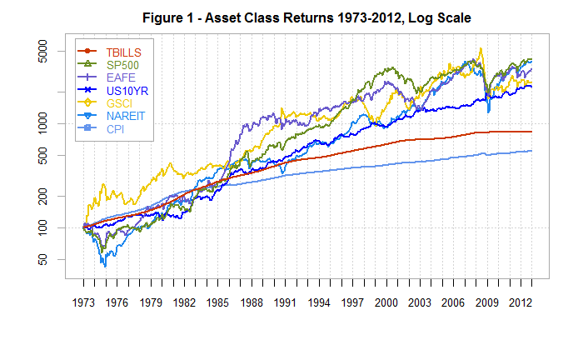Extending this chart to the end of 2016, we can see what has happened over the last 4 years of returns.

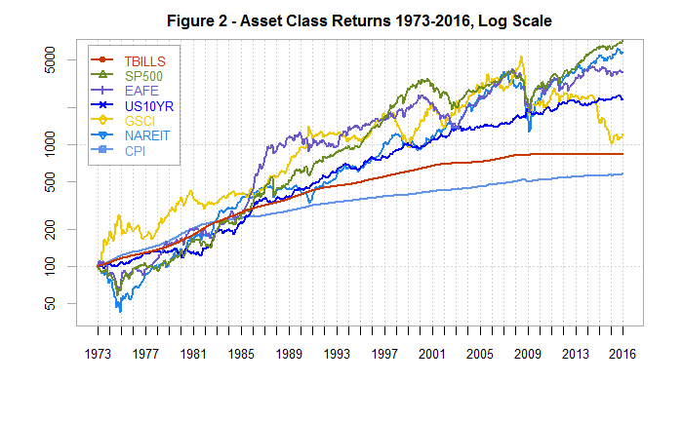

It is clear to see commodities (GSCI) have continued to underperform since its most recent peak in 2008. Zoomed in to confirm its much more obvious.

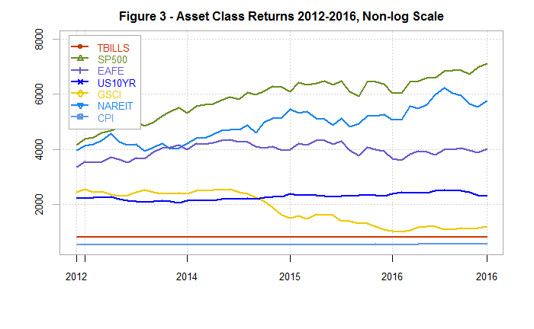

Replicating performance statistics over the same set of asset classes we get very similar results to Faber’s research confirming the visual check above that the data is accurate.

|  |  |  |  |  |  |  |
| --- | --- | --- | --- | --- | --- | --- |
| **Figure 4 - Asset Class Maximum Drawdowns 1973-2012** | | | | | | |
|  | TBILLS | SP500 | EAFE | US10YR | GSCI | NAREIT |
| Return | 5.42% | 9.77% | 9.19% | 8.12% | 8.34% | 9.64% |
| Volatility | 0.95% | 15.71% | 17.60% | 8.47% | 20.55% | 18.16% |
| Sharpe (??%) | 0.00 | 0.26 | 0.20 | 0.30 | 0.13 | 0.22 |
| MaxDD | 0.00% | -50.95% | -56.40% | -15.75% | -67.65% | -68.18% |
| Inflation CAGR | 4.33% | 4.33% | 4.33% | 4.33% | 4.33% | 4.33% |

Comparing to Fabers original numbers we see these small differences: (should this be in appendix with a comment saying comfortable obtained data represents the same asset classes?)

|  |  |  |  |  |  |  |
| --- | --- | --- | --- | --- | --- | --- |
| **Figure 5 - Differences to Faber's Original Research 1973-2012** | | | | | | |
|  | TBILLS | SP500 | EAFE | US10YR | GSCI | NAREIT |
| Return | 0.01% | 0.07% | 0.02% | -0.06% | 0.02% | -0.01% |
| Volatility | 0.00% | 0.02% | -0.01% | 0.03% | 0.00% | 0.03% |
| Sharpe | 0.00 | -0.01 | -0.01 | -0.03 | -0.01 | -0.01 |
|  | 0.00% | 0.00% | 0.00% | 0.04% | 0.00% | -0.30% |
| Inflation CAGR | 0.03% | 0.03% | 0.03% | 0.03% | 0.03% | 0.03% |

Differences here to the original paper are small:

* Differences in returns <0.07%
* Differences in volatility <0.03%

Suspect this is from small differences between data providers. Comfortable using for rest of research.

Next extending this to include 2013-2016:

|  |  |  |  |  |  |  |
| --- | --- | --- | --- | --- | --- | --- |
| **Figure 6 - Asset Class Maximum Drawdowns 1973-2016** | | | | | | |
|  | TBILLS | SP500 | EAFE | US10YR | GSCI | NAREIT |
| Return | 4.93% | 10.18% | 8.75% | 7.41% | 5.85% | 9.65% |
| Volatility | 1.00% | 15.30% | 17.21% | 8.33% | 20.52% | 17.81% |
| Sharpe (5.41%) | 0.00 | 0.33 | 0.21 | 0.28 | 0.04 | 0.25 |
| MaxDD | 0.00% | -50.95% | -56.40% | -15.75% | -80.90% | -68.18% |
| Inflation CAGR | 4.04% | 4.04% | 4.04% | 4.04% | 4.04% | 4.04% |

Looking at the effect of the last 4 years on Faber’s research:

|  |  |  |  |  |  |  |
| --- | --- | --- | --- | --- | --- | --- |
| **Figure 7 - Changes to Asset Class Maximum Drawdowns 1973-2016** | | | | | | |
|  | TBILLS | SP500 | EAFE | US10YR | GSCI | NAREIT |
| Return | -0.49% | 0.41% | -0.44% | -0.71% | -2.49% | 0.01% |
| Volatility | 0.05% | -0.41% | -0.39% | -0.14% | -0.03% | -0.35% |
| Sharpe (5.41%) | 0.00 | 0.06 | 0.01 | -0.02 | -0.09 | 0.03 |
| MaxDD | 0.00% | 0.00% | 0.00% | 0.00% | -13.25% | 0.00% |
| Inflation CAGR | -0.29% | -0.29% | -0.29% | -0.29% | -0.29% | -0.29% |
|  |  |  |  |  |  |  |
| **Figure 8 - Changes to Asset Class Maximum Drawdowns 1973-2016** | | | | | | |
|  | TBILLS | SP500 | EAFE | US10YR | GSCI | NAREIT |
| Return | -8.87% | 4.95% | -4.58% | -9.41% | -29.69% | 0.00% |
| Volatility | 5.26% | -2.49% | -2.27% | -1.30% | -0.15% | -1.77% |
| Sharpe (5.41%) | 0.00 | 0.21 | 0.01 | -0.14 | -0.70 | 0.10 |
| MaxDD | 0.00% | 0.00% | 0.00% | -0.25% | 19.59% | 0.44% |
| Inflation CAGR | -6.05% | -6.05% | -6.05% | -6.05% | -6.05% | -6.05% |

A few noticeable changes stand out:

* Adding 4 more years of data to nearly 40 years of existing data, has reduced the CAGR for commodities CAGR from 8.34% to 5.85%, roughly a 30% reduction drop. The stats also confirm what we see visually with commodities max drawdown increasing to 80%.
* SP500 returns have improved 0.41% and risk reduced 0.41% improving its sharpe ratio.
* TBILL CAGR have dropped – which makes sense considering near zero rates recently.

## Replication of GTAA and extension to include 2013-2016

Looking at the percent of time invested:

|  |  |  |  |
| --- | --- | --- | --- |
| **Figure 10 - Percent of the Time Invested, 1973-2012** | | | |
| Number of Positions | % Invested | # of Months | % of Months |
| 0 (all cash) | 0% | 5 | 1.04% |
| 1 | 20% | 30 | 6.24% |
| 2 | 40% | 56 | 11.64% |
| 3 | 60% | 101 | 21.00% |
| 4 | 80% | 177 | 36.80% |
| 5 | 100% | 112 | 23.28% |
| TOTAL |  | 481 | 100.00% |

Data has one month more with 3 invested/one month less with 4 invested.

Extending to include most recent years:

|  |  |  |  |
| --- | --- | --- | --- |
| **Figure 11 - Percent of the Time Invested, 1973-2016** | | | |
| Number of Positions | % Invested | # of Months | % of Months |
| 0 (all cash) | 0% | 6 | 1.13% |
| 1 | 20% | 32 | 6.05% |
| 2 | 40% | 62 | 11.72% |
| 3 | 60% | 118 | 22.31% |
| 4 | 80% | 192 | 36.29% |
| 5 | 100% | 119 | 22.50% |
| TOTAL |  | 529 | 100.00% |

Looking at most recent years.

|  |  |  |  |
| --- | --- | --- | --- |
| **Figure 12 - Percent of the Time Invested, 2013-2016** | | | |
| Number of Positions | % Invested | # of Months | % of Months |
| 0 (all cash) | 0% | 1 | 2.04% |
| 1 | 20% | 2 | 4.08% |
| 2 | 40% | 6 | 12.24% |
| 3 | 60% | 17 | 34.69% |
| 4 | 80% | 16 | 32.65% |
| 5 | 100% | 7 | 14.29% |
| TOTAL |  | 49 | 100.00% |

Interesting it was out of the market completely at one point. Need to confirm on asset by asset chart!

Looking at the GTAA model.

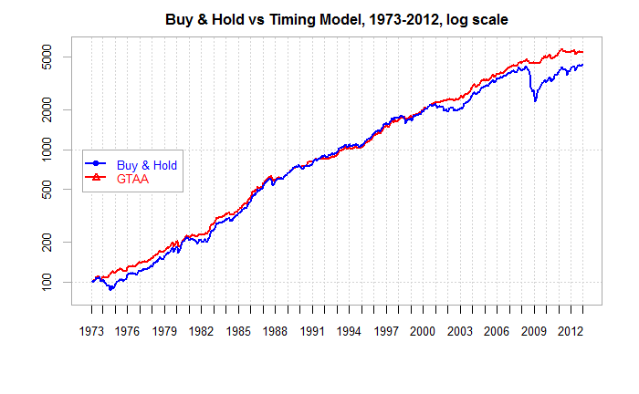

Confirms data and calcs match.

Extending to 2016:

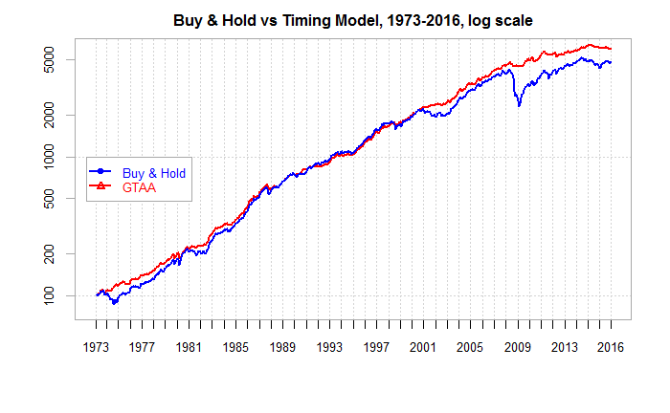

Looking at non log (do I need the replicated or just jump straight into extended?)

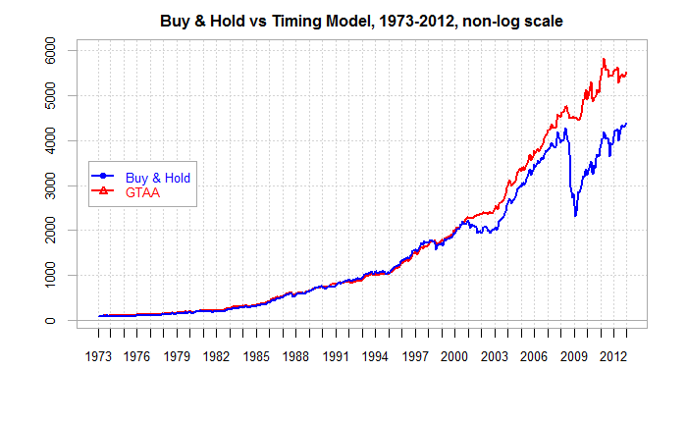

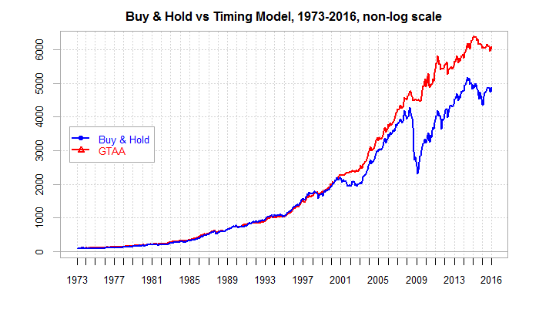

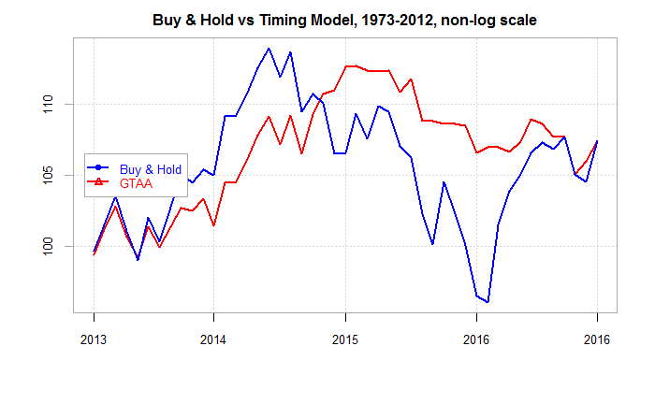

Buy and hold outperformed earlier, then GTAA outperformed with less downside before BH caught up. Look at drawdowns and standard deviation to highlight this point.

|  |  |  |
| --- | --- | --- |
| **Summary Annualised Returns for B&H vs Timing Model, 1973-2012** | | |
|  | Buy & Hold | GTAA |
| Return | 9.93% | 10.57% |
| Volatility | 10.28% | 7.01% |
| Sharpe | 0.41 | 0.68 |
| MaxDD | -46.10% | -9.56% |
| Inflation CAGR | 4.33% | 4.33% |

|  |  |  |
| --- | --- | --- |
| **Summary Annualised Returns for B&H vs Timing Model, 1973-2016** | | |
|  | Buy & Hold | GTAA |
| Return | 9.25% | 9.80% |
| Volatility | 10.09% | 6.87% |
| Sharpe | 0.35 | 0.59 |
| MaxDD | -46.10% | -9.56% |
| Inflation CAGR | 4.04% | 4.04% |

|  |  |  |
| --- | --- | --- |
| **Summary Annualised Returns for B&H vs Timing Model, 2013-2016** | | |
|  | Buy & Hold | GTAA |
| Return | 2.67% | 2.44% |
| Volatility | 7.78% | 4.92% |
| Sharpe | -0.35 | -0.60 |
| MaxDD | -15.62% | -6.74% |
| Inflation CAGR | 1.25% | 1.25% |

|  |  |  |
| --- | --- | --- |
| **Summary Annualised Returns for B&H vs Timing Model, 2007-2016** | | |
|  | Buy & Hold | GTAA |
| Return | 2.67% | 3.89% |
| Volatility | 13.23% | 6.55% |
| Sharpe | -0.21 | -0.24 |
| MaxDD | -46.10% | -9.22% |
| Inflation CAGR | 1.81% | 1.81% |

Look at annual returns. Look at above tables feeding in risk free rates.

Then do for SA.

Save drawdown for SA analysis…

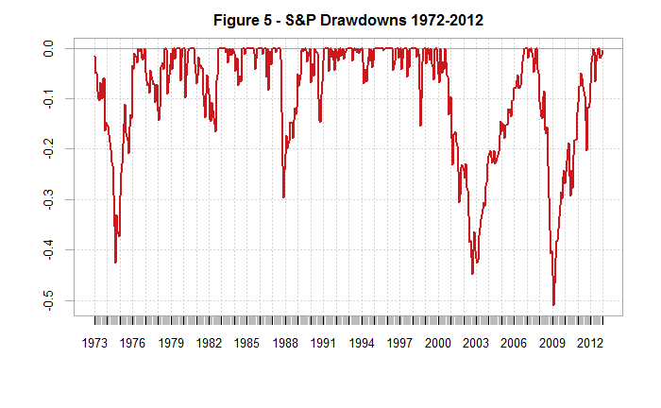

* Need to expand to 1900 – using shiller data?

### Using the 10m simple moving average to manage risk

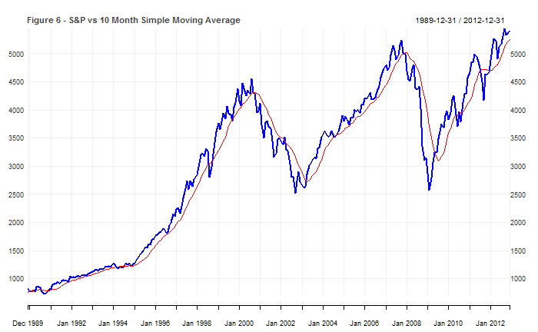

S&P Total Returns vs Timing Total Returns (1901-2012)

SP500 TIMING

Return 9.79 10.29

Volatility 15.69 11.83

Sharpe 0.26 0.38

MaxDD -50.95 -23.29

% Positive Months 60.91 73.60

* Need to expand to 1900 – using shiller data?
* Need to add $100 becomes… CAGR….

### Global tactical asset allocation

## Analysis of the results to determine whether the results are credit

### Key differences and explanations

## Observations

Monthly data so tested on daily/weekly

Effect of all or nothing

## The model applied to a typical SA Asset Allocation

## The model applied to a typical SA Asset Allocation

# Diversification and Modern Portfolio Theory

One of the core drivers of the absolute returns in Faber’s paper is diversification, both for the buy and hold model as well as the timing model.

The benefits of diversification have been acknowledged for thousands of years. Mentioned in the Bible book of Ecclesiastes estimated to be written as early as 935 BC, to more recently within Shakespeare’s Merchant of Venice, diversification is a concept captured simply by the proverb “don’t put all your eggs in one basket”. Basically, invest in a portfolio of risky assets and you’ll always have less risk or equal risk to the riskiest asset.

In 1952 Dr Harry Markowitz published his seminal paper Portfolio Selection introducing practitioners to a mathematical framework that explained the well-known benefits of portfolio diversification. Stating rational investors desired returns and disliked variance, he hypothesised the E-V rule used to create efficient portfolios of diversified securities. Although admitting that diversification could not completely eliminate all variance, using the E-V rule an investor is able to derive an optimal portfolio of assets with either the lowest risk for a given level of expected return or the highest expected return for a given level of risk. Markowitz’s paper notes that although the E-V rule identifies diversification as a driver for more efficient portfolios, it requires the right kind of diversification with a selection of securities with low covariances among themselves. Markowitzs work contributed to what is known today as Modern Portfolio Theory and eventually won him a Nobel prize in 1990.

Modern Portfolio Theory has several criticisms. The risk, return and correlation inputs into the model are based on expected values assumed to stay constant over time and returns are assumed to follow a Gaussian/normal distribution. Recent global market crashes in 1987, 2001 and 2008 have shown these assumptions to be invalid. [insert chart of correlations between 5 asset classes]

Modern portfolio theory has its faults…

Trend following is…. A simple mechanical trend following strategy helps to avoid behavioural biases humans exhibit when making trading decisions.

Faber’s simple 5 asset class equal weighted asset allocation, even on a buy and hold basis, presents evidence of the benefits of diversification. The trend following timing overlay results in reduction of volatility from 20% to 10%. Crucially it reduces drawdowns to the point that the investor only experience one down year since 1973, with that being -1%

The trend following approach counters these faults…

Faber (ivy 2009) highlights that a trend following model will underperform a buy and hold strategy during a strong bull market. He also highlights the timing requires discipline (value of rules based approach) and you can have multiple losing trades in a row. (Humans don’t like being wrong bias).

Trend following isn’t about achieving superior absolute returns – its about avoiding the painful drawdowns which destroyed many previous years of gains.

# Observations of the Faber model

## Tail risk

* Negative skew (koulajian and cskwianianc 2011)
* Faber (2007) identifies that most common asset classes experience painful drawdowns with multiple 40-100% drawdown examples for each asset class.

## Trend following as a solution to modern portfolio selection?

* Trend following is a simple concept – find a trend and follow it. When things move against you or when the trend isn’t there, cut your losses.
* The strategy has had plenty of criticism over the years – especially from classical economists preaching efficient markets – however performance numbers, especially during recent periods of extreme equity markets drawdowns, have increased practitioner followers.
* Drivers of trends (kaminski)
  + Risk transfer (from hedgers to speculators)
  + Process of information dissemination
  + Behavioural biases
* Ultimately trend followers don’t care about the underlying reason.
* Kaminski shows performance statistics from 1223 to 2013 using a simple trend following strategy over a unique dataset for 84 markets in equity, fixed income, foreign exchange and commodity markets. The resulting average returns (13% vs 4.8% for buy and hold) with similar standard deviation (11.2% vs 10.3# for buy and hold) gives the trend following strategy a far superior sharpe ratio (1.16 vs 0.47 for the buy and hold) highlighting the value in actively trading vs passively buying and holding.
* Markets are known to rise on the elavtor fall by the lift
* Trend following is generally rules it mechanically cuts losses and lets winner run – opposite to investors natural instincts. Mechanical strategies remove discretionary decisions which may be subject to behaviour biases. (Covel pg 11)
* “Ilmanen (2011) and Friesen et all (2009) offer explanations as to why trend following may have been successful historically, including the tendancy for investors to underreact to news and their tendancy to exhibit herding behaviour” - trend is our fried clare et all
* Trend following reduces both volatility by being out of markets during substantial periods of devline, reducing drawdowns for the investor.
* Are all asset classes negatively skewed? If so (equities go up the stairs, down the lift) then trend following helps cut the losses. In times of panic, the majority of investors are net long? Panic creates fear of losing. Faster emotional than greed?

## Behavioural issues with the strategy

Although the diversification in the asset allocation reduces volatility risk, investors exhibit behavioural biases which work against the strategy.

Tracking error aversion: investors are likely to track their investment to popular benchmarks like the S&P 500. Any underperformance relative to this benchmark, or even the buy and hold version of the asset allocation, will create doubt for the investor that they have selected the right strategy. Of course with hindsight it will be easy to identify the perfect asset allocation, removing asset classes that have underperformed and replacing them with allocations to the best perofmraning asset allocations. However would investors have been able to stick with this strategy. [Talk about study by newfound about god being a manager and how he would be fired]. Faber identifies his strategy underperforming in bull markets such as the equities market in 1990s. During these times will investors be able to stick to the strategy despite it underperforming each year. [look at rolling returns]. Humans are fickle, every bull market is apparently different and we have learned from the past. Humans greed / fear of missing out compared to the neighbours

Doing nothing: with a timing model investors need to be able to follow the rules – might not be able to sit on their hands. *There is the plain fool, who does the wrong thing at all times everywhere, but there is also the Wall Street fool, who thinks he must trade all the time. Lefevre (reminiscences of a stock operator)*

* *The market does not beat them. They beat themselves, because though they have brains they cannot sit tight. Old Turkey was dead right in doing and saying what he did. He had not only the courage of his convictions but also the intelligence and patience to sit tight.*
* In times of underperformance?

## Further Extensions

* More asset classes:
  + We have only looked at asset classes in these example. Clare et all (2012 pg 8) research shows splitting an asset class into its components parts add value. Although perhaps too time consuming for retail investors, institutional investors could target better risk adjusted returns applying these strategies on individual assets within these broad asset classes.
  + Also add different asset classes – comment on how more and more is becoming available. Perhaps bitcoin as an example of an uncorrelated asset that could improve results.
* Long short model (pg 158 faber ivy)
* No bonds – already exposed to fixed income through treasuries – can remove and increase returns. However this will remove downside?
* High vol asset classes give better returns on a timing strategy (faber ivy 2009)

## Leverage and Portfolio theory

Portfolio theory is you find the optimal portfolio and leverage up. Problem with leverage is it can be fatal for levered investors. Based on volatility. Past volatility. But what does volatility actually mean for an investor. Take 2008 (inker 2010) a levered investor would have been forced to sell…

# Practical implications for Institutional and Retail Investors

Retail costs, behavioural finance aspects of sitting in strategy underperforming, too simple?

Institutional investor benchmarks

# Active vs Passive

Evidence should an active model can consistently beat passive

# Should commodities be removed

Recent research has called for commodities to be dropped from a traditional asset allocation as they have performed poorly… Fabers model shows

# Will the model work with rising interest rates?

# Ideas and tests to improve Fabers approach

* Using EMA
* Using vol filter
* Long and short
* Overlaying a mean reverting
* Pyramid in / out approach

# Appendix – Using R and R code

# References

Inker, B., (2020). “The Hidden Risks of Risk Parity Portfolios”, GMO White Paper

Faber, Meb, A Quantitative Approach to Tactical Asset Allocation (February 1, 2013). The Journal of Wealth Management, Spring 2007 . Available at SSRN: <https://ssrn.com/abstract=962461>

Faber, M., (2007). “A Quantitative Approach to Tactical Asset Allocation”, Journal of Investing, 16, 69-79.

Ilmanen A., (2011). Expected Returns.John Wiley & Sons

Friesen, G., Weller, P. and L. Dunham, (2009), “Price trends and patterns in technical analysis: A theoretical and empirical examination”, Journal of Banking & Finance, 33, 1089- 1100.

Clare, Andrew and Seaton, James and Smith, Peter N. and Thomas, Steve, The Trend is Our Friend: Risk Parity, Momentum and Trend Following in Global Asset Allocation (July 31st, 2015). Available at SSRN: https://ssrn.com/abstract=2126478 or http://dx.doi.org/10.2139/ssrn.2126478